***LAB 2 TASK***

**TASK 1: List one special function of each of the data registers "AX. BX, CX, and DX**

AX: (Accumulator Register)

They are preferred to use in arithmetic and in input/output instruction.

BX: (Base Register)

It is used to serve as an address register.

CX: (Counter Register)

These types of registers store the loop count in iterative operations

DX: (Data Register)

It is used in multiplication and division operations involving larger values

**TASK 3: Write instructions that perform the following operations**.

1. Copy BL into CL = mov CL,BL
2. Copy DX into AX = mov AX,DX
3. Store 0x08 into AL = mov AL,0x08
4. Store 0x3421 into AX = mov AX,0x3421
5. Store 0xFFBC into AX = mov AX,0xFFBC

**TASK 4: Create an uninitialized data declaration for a 64-bit integer**.

* Var1 QWORD ?

**TASK 5: Declare a 32-bit signed integer val3 and initialize it with the smallest possible negative decimal value.**

* Val3 SDWORD -2147483648

**TASK 6: Initialize five 8-bit unsigned integers A, B, C, D& E with the following values: 4, 3, 12, 12, 13. Create another uninitialized 8-bit unsigned integer called val. i. Now write a program to evaluate the expression A +B * C + D – E and store the result in val. ii. (Note: For this example, expression should be resolved from left to right)**

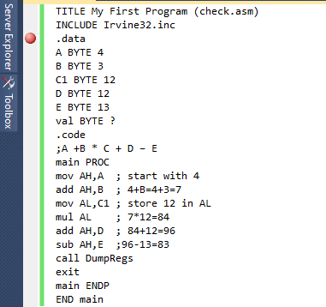

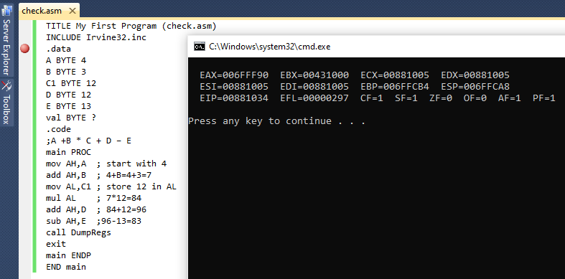

**TASK 7: Fill in the following tables to show storage of 0xDADABABAat address 1996 in the memory of a machine using (i) little endian (ii) big endian byte ordering.**

Address

***BIG ENDIAN***

*LITTLE ENDIAN*

1998

1999

1997

1996

Address

1996

1999

1998

1997

|  |
| --- |
| Contents |
| BA |
| BA |
| DA |
| DA |

|  |
| --- |
| Contents |
| DA |
| DA |
| BA |
| BA |

**TASK 8: What will be the values of the Overflow, Sign, and Zero flags after the following instructions have executed? mov cx,-4097 add cx,1001h**

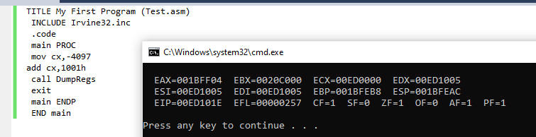

**TASK 9: What will be the value of the Sign flag after following instruction sequences has executed?**

1. **mov cx,8000h add cx,A69Fh**

The value of SF is 0

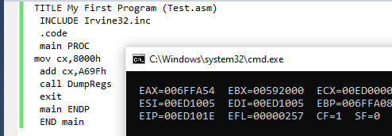

**B) Solve the Q9 (A) in binary format and fill the below register values.**

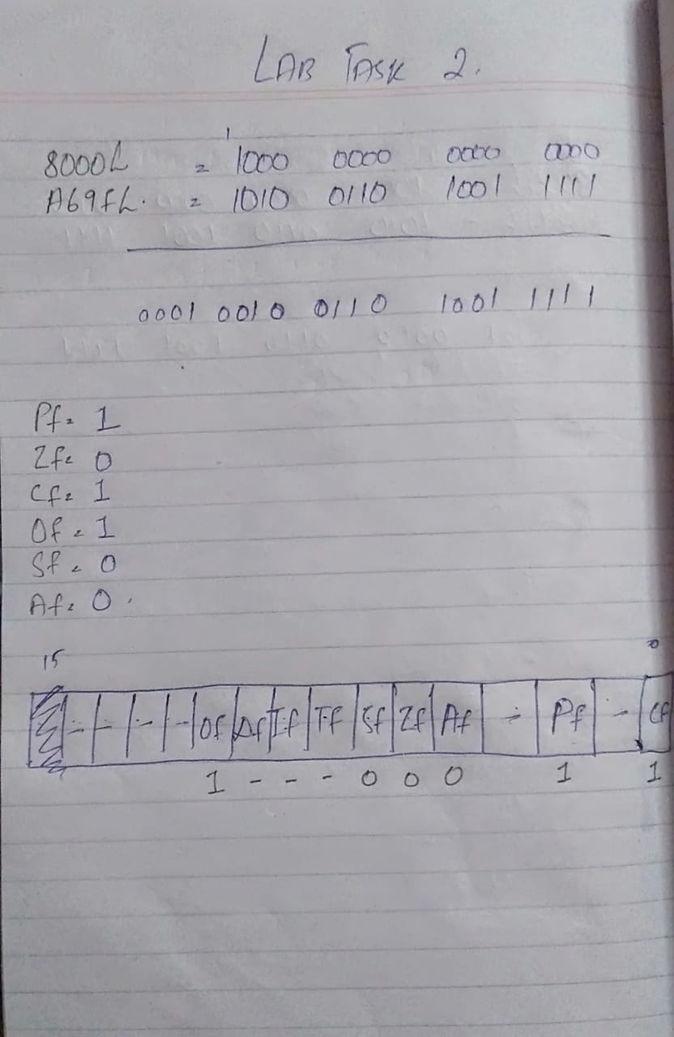

**TASK 10: Write a program in assembly language that implements following expression:**

**ebx = -val2 + val3 *val1**

**Use these data definitions:**

**Var_one word 100**

**Var_two word 150**

**Var_three word 200**

SOL: **I have done this from right to left, so answer will be 19850 and in HEX it will be 4D8A which is being save in EAX.**

